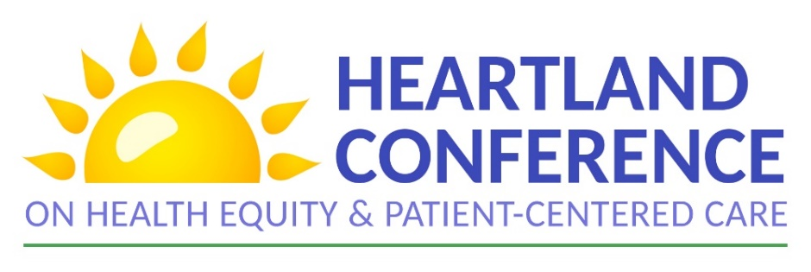

September 9, 2021
AGENDA

EMERGING FROM COVID, FORGING AN EQUITABLE PATH FORWARD IN THE HEARTLAND
9:00 am | Opening & Welcome – Todd Moore, RHEC Co-Chair
9:05 am | Sponsor Welcome
 | Chris Beurman, Director Community Development, Aetna Better Health of Kansas
 | Patrick Sallee, President & CEO, Vibrant Health
Danielle Jones, PhD, Director of Diversity and Health Equity,
American Academy of Family Physicians
Danielle Binion, MA, Director for Diversity, Equity, and Inclusion,
University of Kansas Medical Center
9:25 am | RHEC Welcome & Agenda – Todd Moore, RHEC Co-Chair
9:35 am | Call to Action - Broderick Crawford, NBC Community Development Corp. Executive Director
9:45 am | Participant Networking *participants randomized into smaller groups
10:00 am | Concurrent Breakout Sessions:  Health Equity Informed Public Response: COVID as a Case Study - RADx-UP  Broderick Crawford, Executive Director, NBC Community Development Corporation  Erin Corriveau, MD, MPH, Associate Professor, Family Medicine & Community Health, Population  Health  K. Allen Greiner, MD, MPH, Vice Chair of Family Medicine & Community Health  Health Equity Implications of Extreme Weather in the Heartland  Jasmin Moore, MSCRP, AICP, Director of Sustainability, City of Lawrence and Douglas County, KS  Mental Health and Health Equity – Just Like A Hero  Donna L. Wilson, PhD, LPC, Director of Operations and Community Engagement, Mental Health  Center of Denver  Vladmir Sainte, Author/ Artist, Team Leader, Truman Behavioral Health  Improving Adolescent Access to Care  Melissa K. Miller MD, MsCR, Professor of Pediatrics at the University of Missouri-Kansas City School  of Medicine  Romina Loreley Barral, M.D., MsCR, Assistant Professor of Pediatrics, University of Missouri Kansas  City School of Medicine, MO
10:50 am | Break
11:00 am | Participant Networking *participants randomized into smaller groups
11: 20 am | Heartland Health Equity Awards presented by HUMANA
11:45 am | Lunch Break
12:10 pm | Keynote Introduction – Catherine Satterwhite, PhD, MSPH, MPH, Regional Health Administrator, Office of the Assistant Secretary for Health, Office of Regional Health Operations, Region 7
12:15 pm | Keynote Speaker – Marcella Nunez-Smith, MD, MHS, Senior Advisor to the White House COVID-19 Response Team
12:45 pm | Integrating Health Equity into COVID-19 Strategies with Region VII  Panelists:  Robert J. Knodell, Acting Director, Missouri Department of Health and Senior Services  Charity Menefee, Director of Operations- Public Health, Nebraska Department of Health and Human  Services  Joan Duwve, MPH, MD, Deputy State Health Officer, Kansas Department of Health and Environment  Kelly Garcia, MPA, Director, Iowa Department of Human Services  Caitlin Pedati, MD, MPH, FAAP, Medical Director, Iowa Department of Public Health
1:45 pm | Participant Keynote Conversation Debrief *participants randomized into smaller groups
2:00 pm | Break
2:05 pm | Q&A with Panel
2:30 pm | Concurrent Breakout Sessions:  Health Equity: The Elephant in the Room  Naiomi Jamal MD, MPH, CMQ, Chief Quality Officer, Swope Health and Clinic Director, Swope Health  Independence  Community Health Workers Response to COVID-19 in the Heartland  Guadalupe Tredway, Community Health Worker, CHC Wyandotte County  Carla Moralez, Community Health Worker, CHC Wyandotte County  Alma Vargas, Community Health Worker, CHC Wyandotte County  Dr. Manuel Solano, Program Director, CHC Wyandotte County  HRSA COVID-19 Health Equity Efforts  Kim Shiu, Public Health Analyst, Health Resources and Services Administration, Region VII  Nancy Rios, Regional Administrator, Health Resources and Services Administration, Region VII  Birth Equity in the Heartland  Sharla Smith, PhD, MPH, Assistant Professor in the Department of Population Health and  Department of Obstetrics and Gynecology at the University of Kansas School of Medicine-Kansas  Hakima Payne, Executive Director, Uzazi Village  Mariah Chrans IBCLC, PhD, Program Director Cradle Kansas City, Community Health Council of  Wyandotte County, KS  Let Your Community Guide You: Listen to The People  Dustin Hare, Co-founder of Mutual Aid WyCO  Kim Weaver, Co-founder of Mutual Aid WyCO
3:15 pm | Break
3:20 pm | Participant Networking *participants randomized into smaller groups
3:40 pm | Closing Call to Action – Josie Rodriguez, RHEC Co-Chair
4:00 pm | Adjourn

